Lab 01 - Installing VMs
Lab Report

Taking a snapshot
- There will be times when you may want to save your progress on a VM. In order to do this, we will create what is called a “snapshot”. A snapshot is a saved state of a machine that you can revert back to if something were to break. To create a snapshot, right click on your machine you wish to save.
- Hover over “Snapshots” and click “Take Snapshot…”

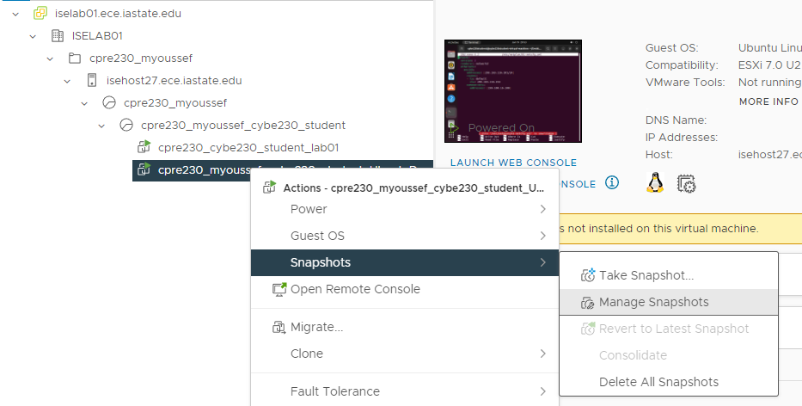

- Name the snapshot whatever you want, fill out a description, and click “ok”.
  - To revert to a snapshot, repeat step 1 but instead taking a snapshot, select “Revert to Latest Snapshot”. Note: All progress after the latest snapshot will be lost.
- Snapshots use storage space on the cpre230 datastore. You do not need to make them after every step in a lab. But you may want to make a snapshot before every major change you make (adding a new service for example). That way it is easy to revert if you have an oops during configuration.

- Successful output of ip addr to show your statically set IP information is correct
(15 Points)

- Successful output of ping to your default gateway
(15 Points)

- Screenshot of Iowa State’s homepage successfully loading in firefox
(10 Points)

File | Why is editing this file necessary when setting up my network settings?
/etc/netplan/01-netcfg.yaml
(20 Points)

/etc/environment
(20 Points)

/etc/profile
(20 Points)

